**IriEnvoy-MK**

**Basic User’s Guide**

Version 2.2, December 2023





Document version 1.0

**Document Change Record**

This page records any updates and revisions to the IriEnvoy-MK Basic User’s Guide.

|  |  |  |  |
| --- | --- | --- | --- |
| Doc ver. | Date | Change Description | SDK ver. |
| 1.0 | 2023.03.27 | Initial version | 2.32.25 |
| 2.0 | 2023.04.25 | Revised version | 2.32.26 |
| 2.1 | 2023.04.26 | Revised version | 2.32.26 |
| 2.2 | 2023.12.20 | Revised version | 2.32.26 |
|  |  |  |  |

**Notice**

The information contained herein is provided solely for the purpose of allowing customers to operate and integrate IriTech’s hardware and software and is not to be released, reproduced, or used for any other purpose without written permission of IriTech, Inc.

IriTech reserves the right to make changes on this hardware and software with the intent to improve its functionalities. Information and specifications contained in this document are subject to change without prior notice and do not represent a commitment on the part of IriTech.

© 2023 by IriTech, Inc. All rights reserved.

**Table of Contents**

1 Preface 4

1.1 Purpose of this Document 4

1.2 Intended Reader 4

1.3 Other Documentation 4

1.4 Contact Information 4

2 Introduction 5

3 Item Inventory 5

4 Warnings and Precautions 5

6 Getting Started 8

6.1 Hardware Setup 8

6.2 Demo Software (IriEnvoy-MK Iris Capture Demo) Installation 8

6.2.1 Installations in Windows 10 8

7 Conditions for Using USB 14

7.1 Using USB 2.0 14

8 Camera System Operation 15

8.1 Possible Problems with USB Connection 15

8.2 Proper Orientation of the User 16

9 Using “IriEnvoy-MK Iris Capture Demo” demonstration software 18

9.1 Device setting 18

9.2 Iris image capturing 21

9.2.1 Auto Capture Mode 21

9.2.2 Operator Capture Mode 22

9.3 How to change capture setting 23

9.3.1 Capture Mode (Time-Based vs Frame-Based) 23

9.3.2 Streaming option 24

9.3.2.1 Streaming scale 24

9.3.2.2 Streaming image format 25

9.3.3 Result image option 25

9.3.3.2 Image kind 25

9.3.3.3 Image format 26

10. Troubleshooting 28

10.1 Preventing Dark, Mismatching, or Blurry Images 28

10.2 Preventing Occlusion 28

10.3 Preventing Side Gazing & Partial Iris 29

10.4 Preventing Reflection on Glasses 29

11 FAQ 31

11.1 Questions about the Camera Hardware 31

11.2 Questions about Software Installation 31

11.3 Questions about Image Files 32

11.4 Questions about the Image Capture Process 32

12 Legal Notice 34

12.1 Warranty Agreement 34

12.2 End-User License Agreement 38

# 1 Preface

## 1.1 Purpose of this Document

This Basic User’s Guide explains how to conduct simple demonstrations of the IriEnvoy-MK hardware using your PC and the included demonstration application. It includes guidance on the best way to optimize the equipment, and reviews the capture process, and suggests how to maximize the quality of iris images.

## 1.2 Intended Reader

This document is written for a broad audience, ranging from business managers, to salespeople, to engineers. Readers of this manual are assumed to have little knowledge of electronics or software. There is no presumed knowledge about any aspect of the IriEnvoy-MK or the field of biometrics.

## 1.3 Other Documentation

For additional information about this product, see the following documents:

* IriEnvoy-MK HW Developer’s Manual – detailed technical overview of the hardware in order to start integrating as a solution
* IriEnvoy-MK SW Developer's Manual – useful tips for IriEnvoy-MK SDK
* IriEnvoy-MK API Reference Manual – a detailed listing of the Application Programming Interface (API)

## 1.4 Contact Information

If you have any questions or experience any problems using this hardware, please contact:

Phone: 1.703.877.2135 (USA)

82.2.872.3812 (South Korea)

Email: collaboration@iritech.com

Your feedback is important in helping to provide the most accurate and highest quality information. If you have any comments about this documentation, please send us an email. Include the version of this document and the location of the information you are commenting on (for example, a page or section number).

# 2 Introduction

Ready to be used as a portable iris camera for the added protection of superior iris recognition technology, IriEnvoy-MK is the perfect choice for security needs when budget is a factor or a huge number of iris cameras are required. This monocular device is a revolutionary design that delivers high-quality iris acquisition with unprecedented ease-of-use. IriEnvoy-MK provides true contactless, fast, ISO-compliant acquisition in an attractive housing that can be handheld conveniently. With its USB interface, compact hardware design, sophisticated and easy to integrate accompanying software, the IriEnvoy-MK represents incredible value for iris biometric identification.

# 3 Item Inventory

You will need the following items to operate the IriEnvoy-MK in demonstration mode:

* IriEnvoy-MK camera unit
* Software Package containing:
  + IriEnvoy-MK Iris CaptureDemo demonstration application
  + IriEnvoy-MK C++SDK Software Development Kit

(Please contact IriTech <collaboration@iritech.com> to get an account to download all software packages from IriTech’s website).

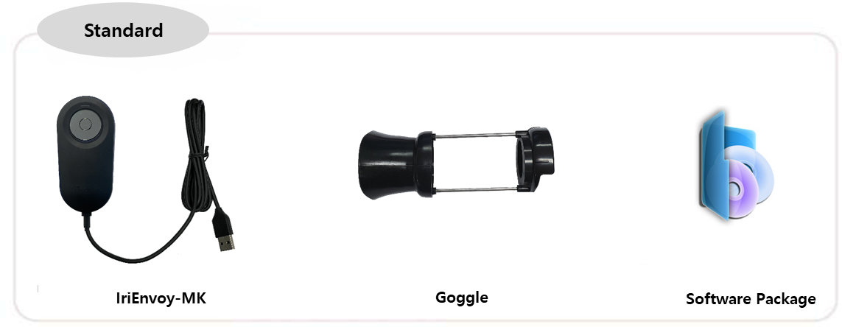

# 4 Warnings and Precautions

IriEnvoy-MK includes sensitive electronics and optics. It is possible for IriEnvoy-MK device to get these electronics damaged if you do not follow proper precautions:

* Clean regularly to remove dust, but do not use any cleaning solutions. Only wipe the device with a smooth cloth or towel. Keep the lens free of dust and dirt, and use a special cloth for optics in order to avoid scratching the optics.
* Do not allow water to leak into the device or operate the device in humid conditions where water might condense upon the electronics.
* Do not operate device in places where temperature reach extremes beyond the stated range.
* Do not place the device next to heating equipment.
* Do not place magnets near the device.
* Do not apply voltage or current beyond the stated range.
* Do not use the device for any purposes beyond those specified.
* Do not disassemble components from the boards or alter wiring or board design.
* Do not drop the device or submit to sudden impact or mechanical stresses.
* Handle the electronics with proper anti-static protection and techniques to prevent shorting any microchips.

**Any damage to the device caused by these activities will void the warranty.**

**5 Operating Conditions**

5.1 System Requirements

* Window 10 (32 bit/ 64bit)
* PC processing speed of 1.6 GHz or higher preferred
* PC support of USB 2.0 preferred for smooth data streaming

5.2 Lighting Conditions

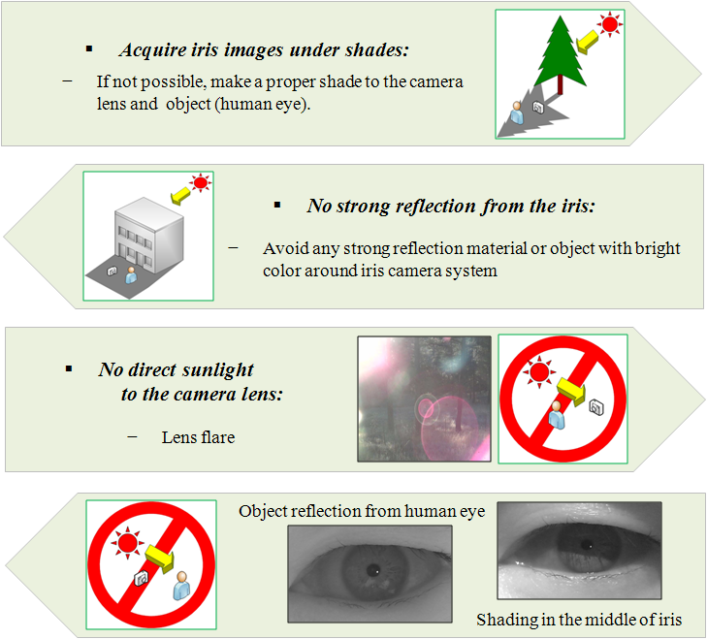The IriEnvoy-MK can capture iris images indoors and outdoors, but special care must be taken to avoid strong sunlight that will disturb image quality:

The following materials might reflect sunlight onto the camera or user if outdoors:

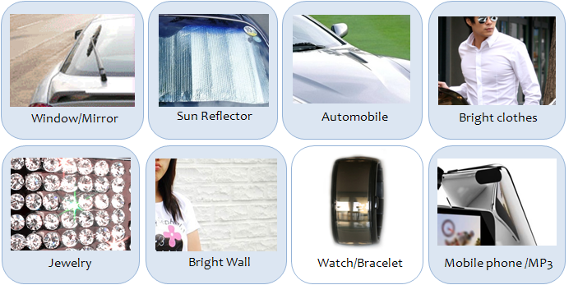

If sunlight is a problem, shade the user or equipment when implementing the camera outdoors:

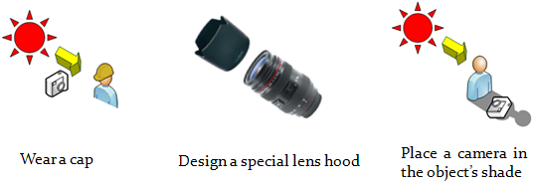

# Getting Started

## Hardware Setup

* Plug the other end of the USB cable into the PC’s USB 2.0 port.

**NOTE**: Before software installation, you should have in your PC the IriEnvoy-MK software package downloaded from IriTech’s website.

## Demo Software (IriEnvoy-MK Iris Capture Demo) Installation

### Installations in Windows 10

#### IriEnvoy-MK Iris Capture Demo

The IriEnvoy-MK Iris Capture Demo application must be installed in order to demonstrate the camera. Please follow the instructions below to install this software:

**Note:** The Demonstration Software version in the screen may differ from users since this is an example of how to install the application. Also, the software version is subject to change without notice.

1. Under the “capture_demo” folder, choose the **Version** folder and then “**Release**” folder. Double Click the “**setup.exe**” file.

(F:\capture_demo\2.32.26)

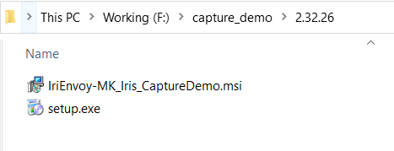

1. Then the Setup Wizard will appear. Click “**Next**” for setup.

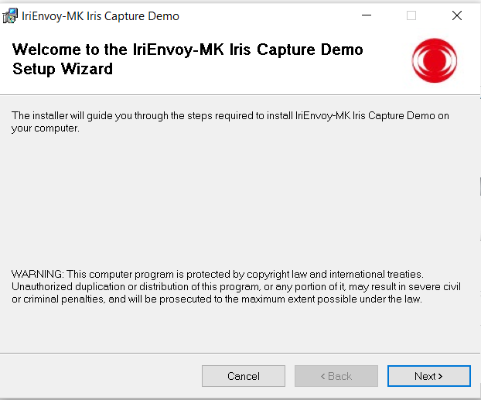

1. If you want to install this program in a different folder, click “**Browse**” and specify the desired folder. If not, then just click “**Next**” to continue on.

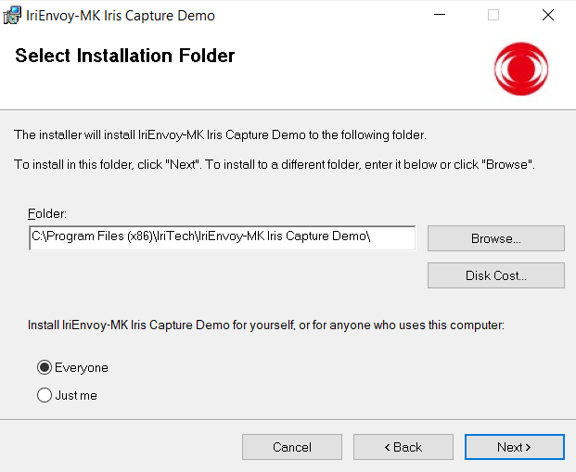

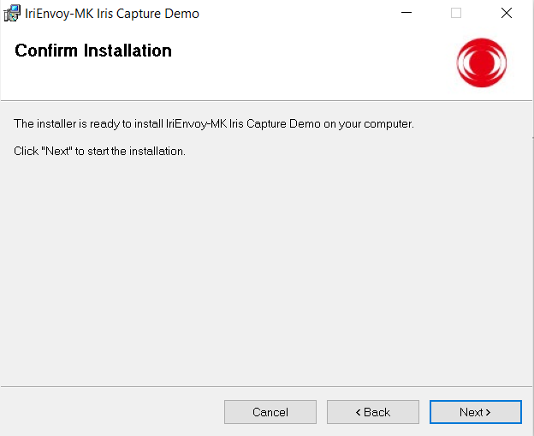

1. You will be asked to agree to license terms. Read, select “**I Agree**”, and then click “**Next**”.

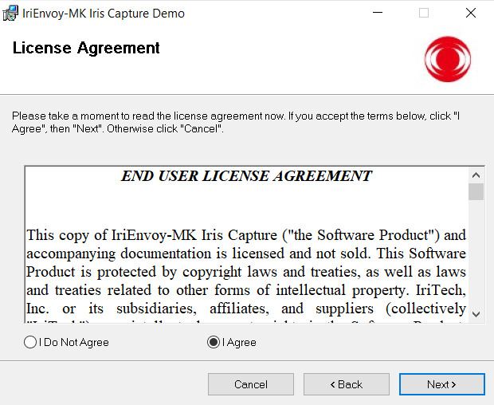

1. If you clicked “**Next**,” the Capture_Demo application will automatically begin installation. Once it is complete, click “**Close**.”

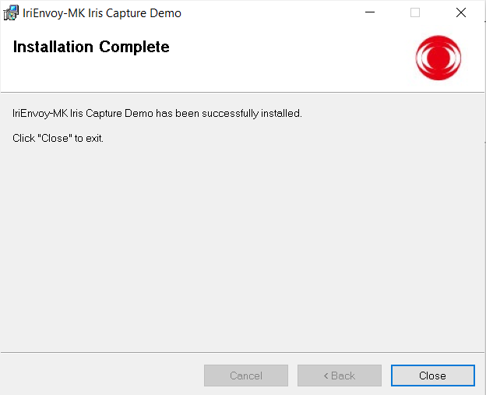

1. After setup, you can verify if the program is properly installed by examining the correct folder location on your computer.

(C:\Program Files (x86)\IriTech\IriEnvoy-MK Iris Capture Demo)

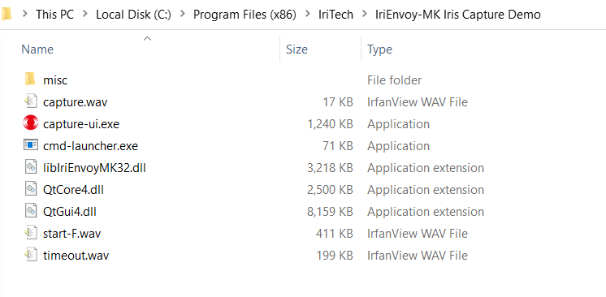

#### Device Driver Installation

IriEnvoy-MK uses Microsoft’s default USB Video Class (UVC) driver, available in all Microsoft Windows distribution.

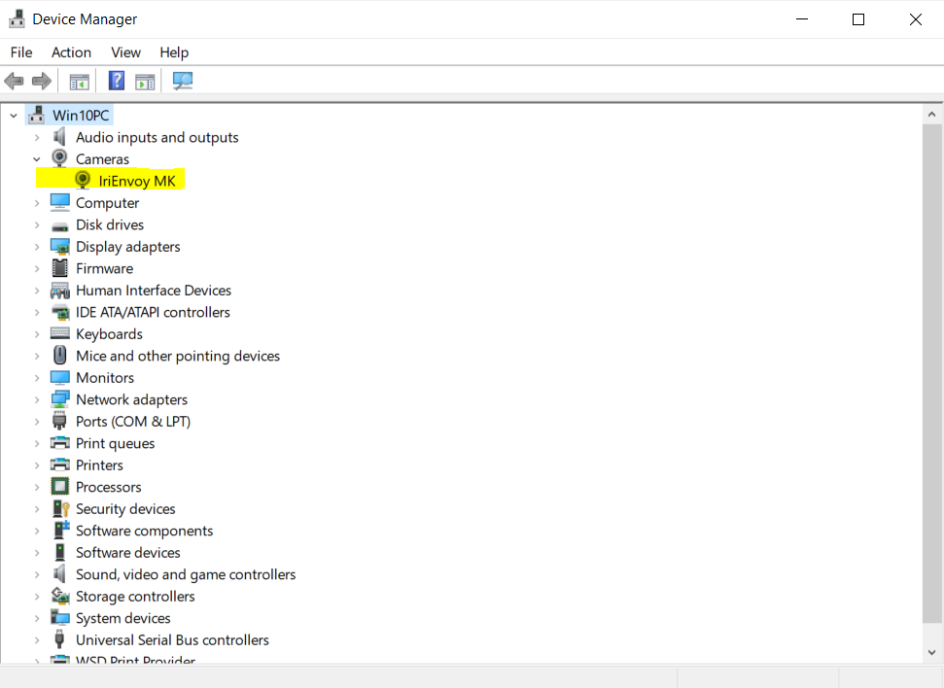

# Conditions for Using USB

## 7.1 Using USB 2.0

* The PC must be equipped with a USB 2.0 Host Adapter and have USB devices that support USB 2.0 (ex. USB2.0 PCI CARD, etc.).

You can verify the above conditions in the Device Manager provided by MS Windows

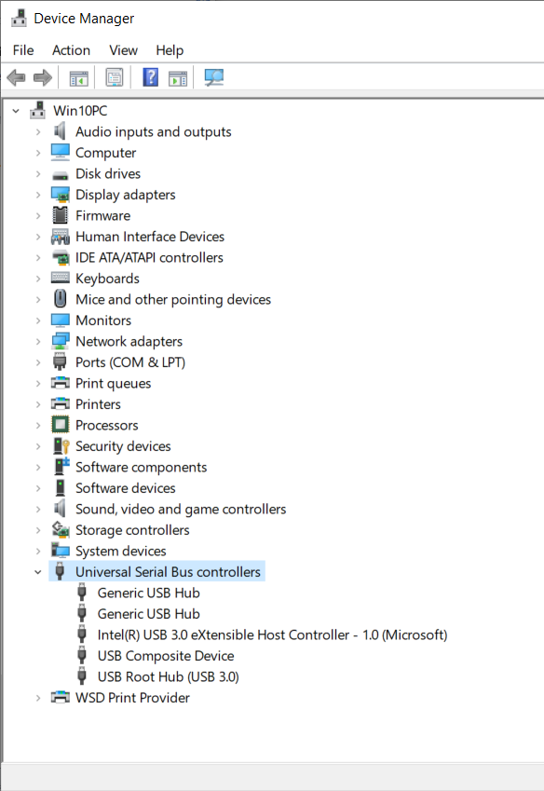

# Camera System Operation

## 8.1 Possible Problems with USB Connection

We have encountered some cheap computers with USB ports sloppily implemented. Please make sure you use properly implemented USB ports. However, most of the time, you won’t have any problems setting our products if your computer has properly implemented USB ports. Just in case if you have any problems with USB connections, please try the following suggestions:

* **Snug fit**

Some USB ports are loose so that USB devices can’t be snug fit into the port. In this case, due to unstable connection, the device may stop working sporadically. If you see this problem, please try another better-made USB port. (You may have experienced this problem even with a flash memory stick.)

* **USB ports**

Our device draws the current of 600mA at the peak while a typical USB port’s maximum current supply is capped at 500mA. But in a rare case, some USB ports are implemented in such a way that one port is branched out into two physical outlets. In such a case, the sum of currents from these two ports may be capped at 500mA. If our device is inserted into such ports, it cannot function properly due to lack of sufficient current. (You may have experienced a similar problem with an external USB hard disk that used two cables.)

* **Missing USB Drivers /or Incorrect Driver Versions**

Sometimes the problem is in the drivers. By installing those for your OS, you might be able to resolve the issue.

* **Using Device Manager**

You can use Add New Hardware to detect new components. Trying this option can help fix USB device problems. In Windows Control Panel, double click the Add New Hardware icon. Let Windows run a scan of all devices on the system.

* **Remove and Reinstall all USB Controllers**

If the above mentioned suggestions do not help, try this one. Right click the Start Menu and choose Search. Type “sysdm.cpl”. When the file appears, double click it. You will be able to access the Device Manager. Right-click every device under the Universal Serial Bus Controllers node, and then click Uninstall to remove them one at a time. Restart the computer, and then reinstall the USB controllers.

* **USB hub/USB extension cable**

USB hub or USB extension cable can be troublesome, try to connect camera directly to USB port of your system.

* **Reboot your system**

Turn off your computer using Shut Down and then unplug it from the wall outlet. Let it sit for about a minute and then plug it back in.

* **Other possible Solutions**

After plugging in the device, reboot the system. Normally this step would not be necessary but there are times when it does help.

Even though you have tried all our suggestions above and still it doesn’t work, please contact us by calling at +82-2-872-3812 or by email at collaboration@iritech.com. We are willing to support and help you in any situation.

## 8.2 Proper Orientation of the User

During the capture process, the user must be properly oriented to the camera. Otherwise, capture may not be possible or very little of the iris will be visible. Here are examples of good and bad orientation:

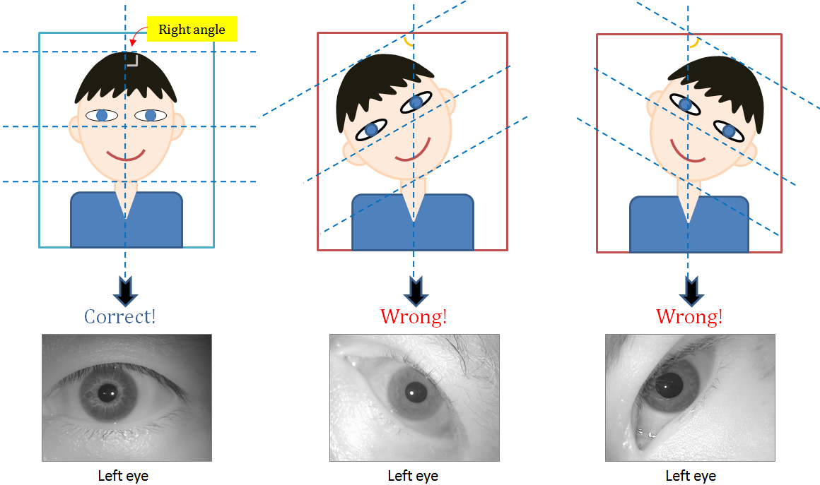

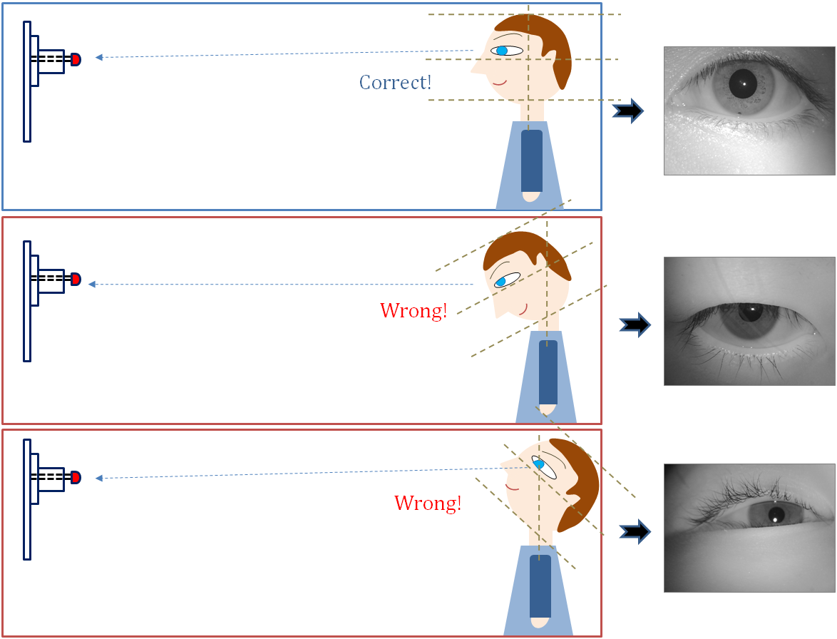

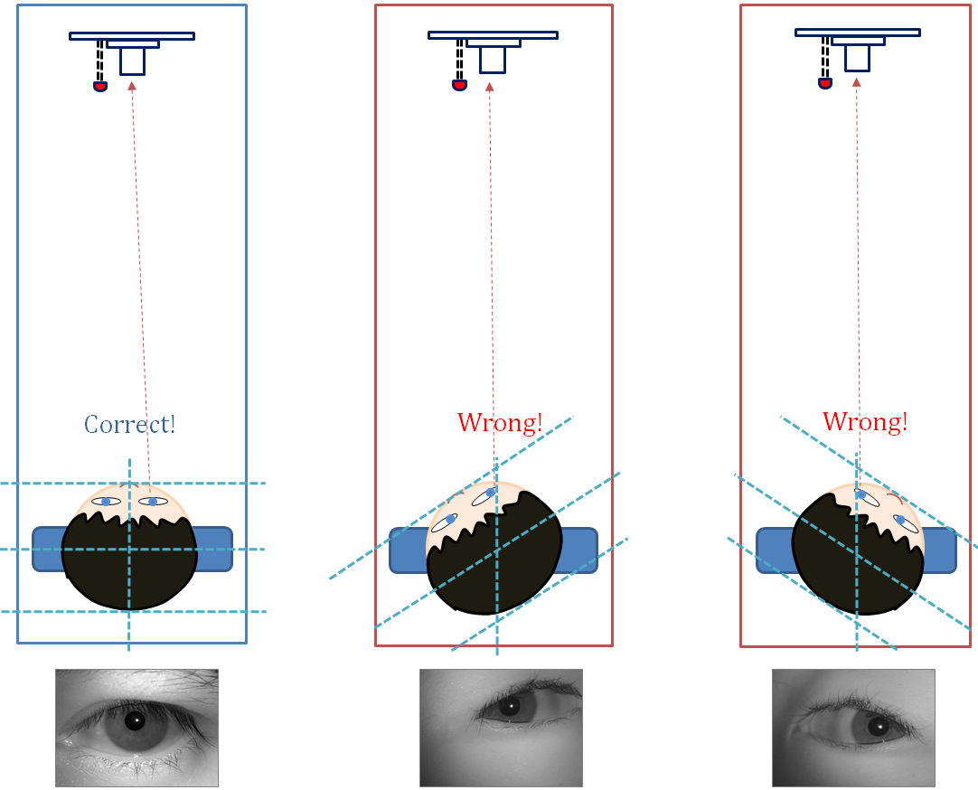

# Using “IriEnvoy-MK Iris Capture Demo” demonstration software

The following demonstration for IriEnvoy-MK Iris Capture Demo is performed on Windows as an example. The process on other operating systems can be executed exactly the same.

* For Windows 10, IriEnvoy-MK Iris Capture Demo application can be started from “C:\Program Files (x86)\IriTech\IriEnvoy-MK Iris Capture Demo \capture-ui.exe”.

## Device setting

This section must be done before any further functionalities of the program get ready to work.

1. Click on the “Device Setting” button.

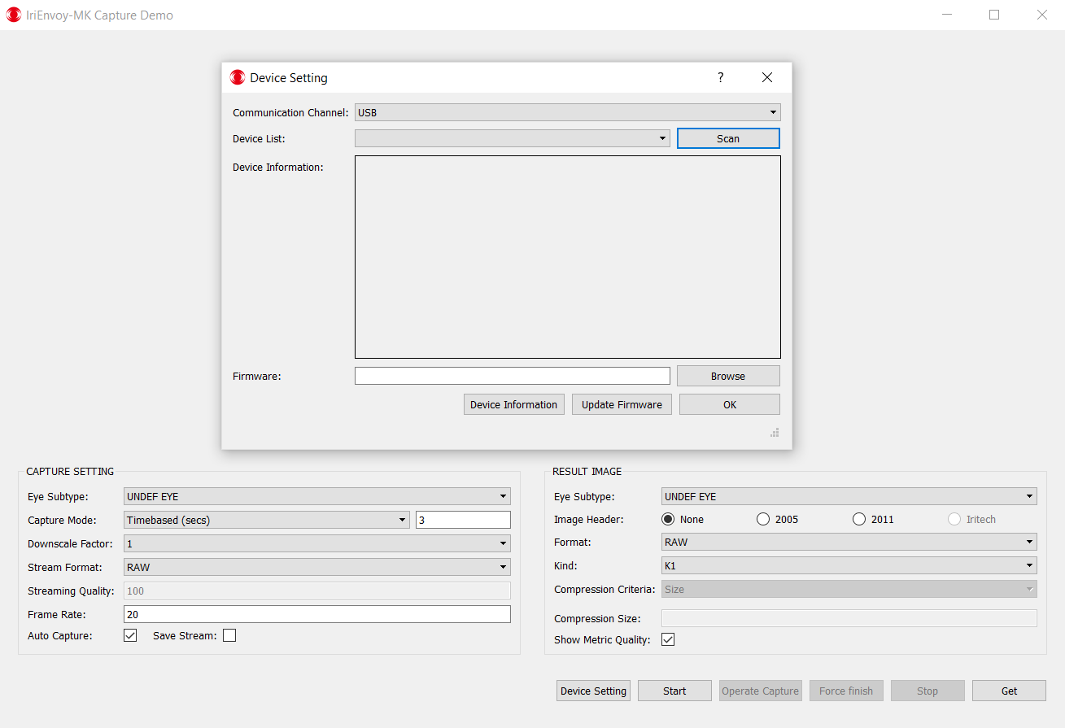

1. Select the “communication channel” from combo box

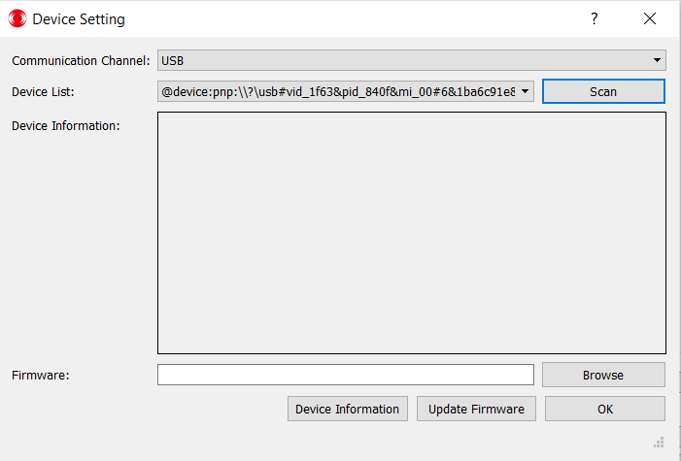

1. Click on button “scan” to refresh list and IriEnvoy-MK device in case USB communication is selected.

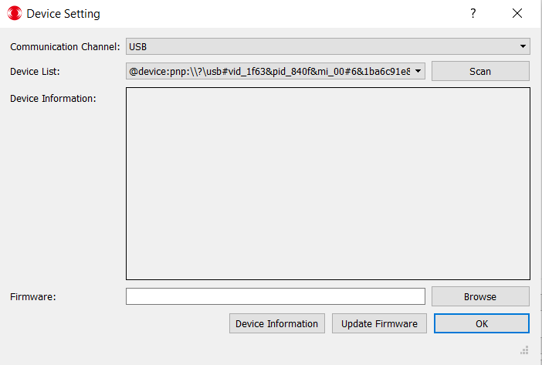

1. To view more information about the selected device, press “Device Information”.  
     
   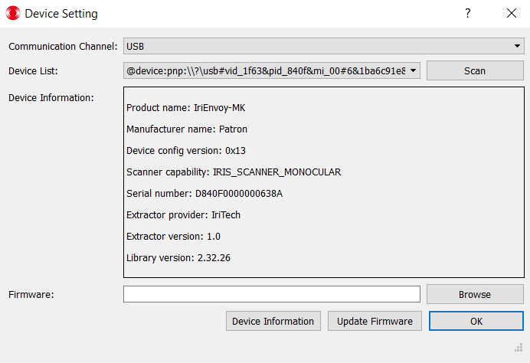

## Iris image capturing

### Auto Capture Mode

1. Click the “**Start**” button to activate the camera.

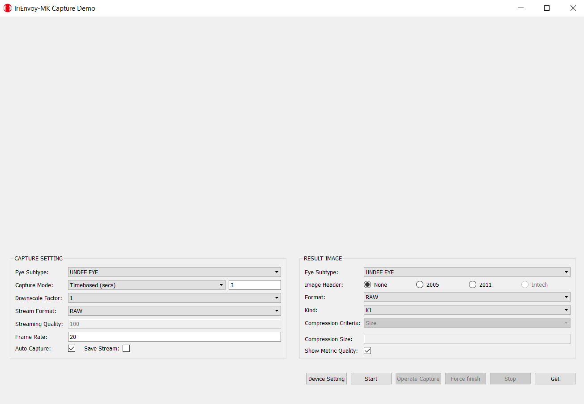

1. Position the user’s eye to look directly at the mirror on the camera at a distance of about 20 cm (8 in) in front of the camera.
2. The user should open eyes wide and make sure that the iris is reflected on the mirror attached to the top of the camera.
3. The user must approach the lens slowly to bring the iris into focus. The optimal location is 15.5 cm (6.1 inches) away from the front of the camera mirror. The BLUE LED of the device will **BLINK** when it has detected its first qualified iris image and started capturing iris images.
4. Once The BLUE LED of the device was **BLINK**, it is best to remain still or move very slowly toward the camera until The BLUE LED was not BLINK and stop turns on, indicating that it has selected a qualified iris image.
5. If there is a satisfactory qualified image from among the captured images, the procedure is complete, otherwise, an error message appears on the computer “No frame was qualified. Please try again.”

### Operator Capture Mode

When there is an operator,

1. The operator unchecks the “**Auto Capture**” mode and clicks the “**Start**” button.

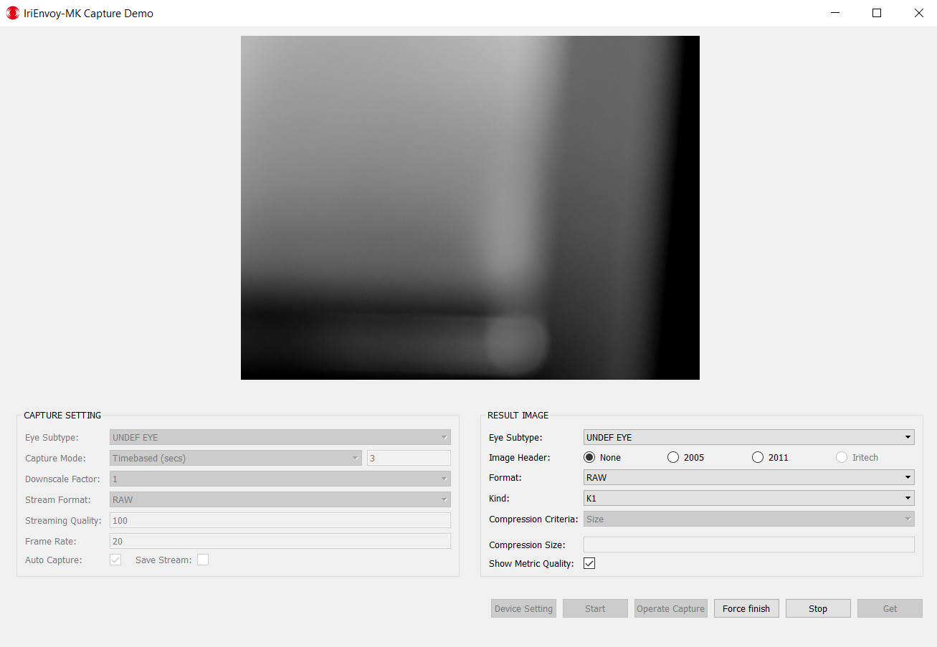

1. Operator looks at the streamed images on the screen and when he/she decides good and sharp iris patterns have appeared, he/she presses the “**Operate Capture**” button.

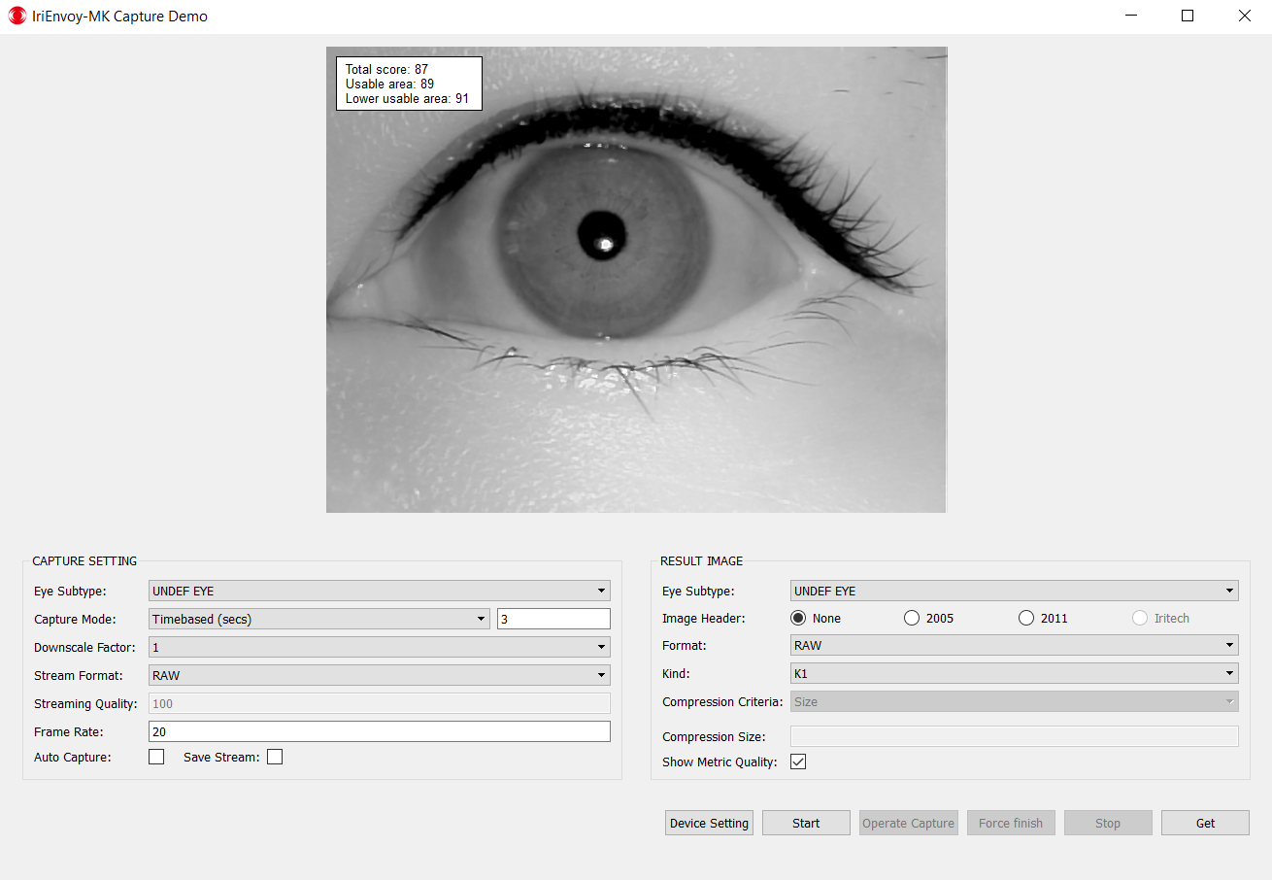

1. Once the “**Operate Capture**” button is pressed, the lens starts to move and captures a whole bunch of images and evaluates their qualities and selects the best frame.
2. The Operator Capture process ends.

**Note:**

* If power is disconnected to the camera, such as during closing a laptop, it will take a few seconds after power is reestablished for the camera to operate as normal. See Section 9.4.

## How to change capture setting



### Capture Mode (Time-Based vs Frame-Based)

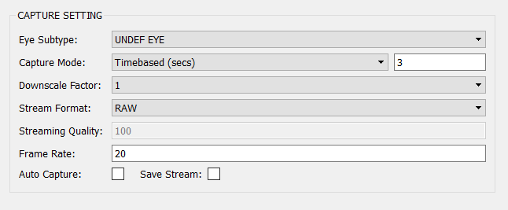

In Time-Based Capture Mode, the capturing time period (in seconds) is specified as the length of time to capture all qualified eye image frames. When the capturing period times out, the application will choose the best quality image from the collection of qualified frames. If this image satisfies the Minimum Quality Tolerancecondition as set in the Quality Mode, the application will return this frame. If no frame meets the minimum quality, the application will ask the user to attempt capture again.

In Frame Based Capture Mode, the number of qualified images stored is specified. The best image will be selected from these qualified images and checked against the Minimum Quality Tolerance condition.

### Streaming option

The streaming images display on the demo application.





### 9.3.2.1 Streaming scale



Streaming scale changes the size of streaming images (therefore increases streaming frame rate) to support smoother streaming when USB is not high-speed.



### Streaming image format

1. The RAW and JPEG format is supported.

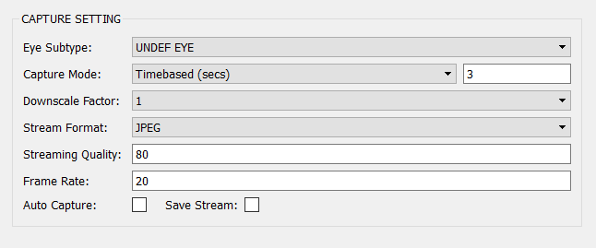

### Result image option

### Image kind

The IriEnvoy-MK device provides the K1, K2, K3, K7 image kind option for retrieving qualified iris images.

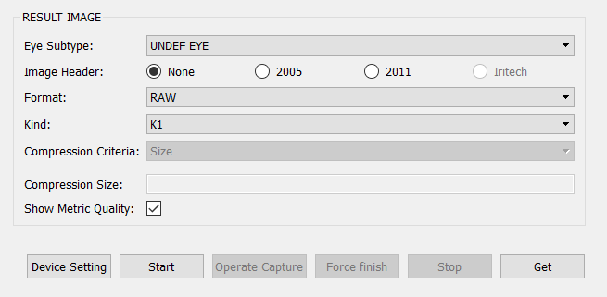

### Image format

1. RAW and JPEG, PNG, JPEG2000 are supported for the resulting image.

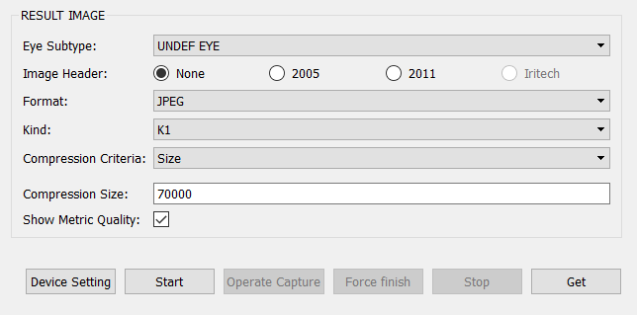

1. If JPEG, PNG, JPEG2000 is selected, a compression ratio in range [1,100] needs to be specified.

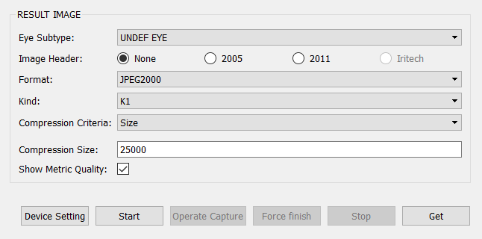

# Troubleshooting

## 10.1 Preventing Dark, Mismatching, or Blurry Images

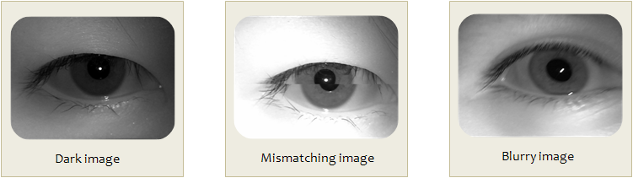

***Cause:*** Infrared LED is not positioned correctly or the user’s movement is too fast.

***Solutions:***

* Check the LED angle to make sure it is positioned as described in Section 8.1.
* Don’t move quickly in front of the camera; slowly approach the mirror in front of the camera barrel.

## 10.2 Preventing Occlusion

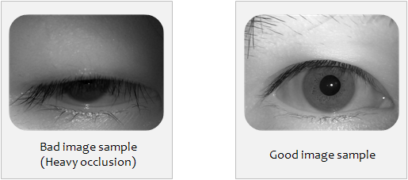

***Cause:*** The upper eyelid and eyelashes cover most of the iris.

***Solution:***

* Open eyes widely while approaching the camera so that the camera is able to capture the user’s iris.

## 10.3 Preventing Side Gazing & Partial Iris

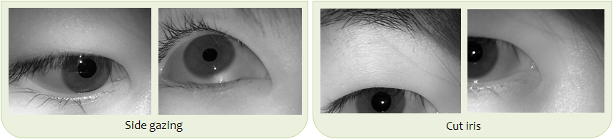

***Causes:*** The user was not aligned properly with the camera, or was looking to the side of the camera. Such images may result in capture failure or wrong iris recognition.

***Solution:*** The user should look into the mirror attached to the front of the camera and make sure that the eye appears in the middle of the circle.

## 10.4 Preventing Reflection on Glasses

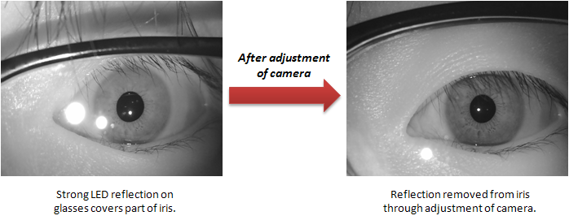

***Causes:*** The infrared LED illumination is reflecting off the user’s glasses and back into the camera. This creates a bright glare that is covering part of the iris in the image.

***Solutions:*** Adjust the infrared LED or the angle of the camera until this problem is minimized or disappears. Having the camera perfectly horizontal and parallel has the greatest tendency to cause a reflection. See the diagram below for guidance. Unfortunately, each type of glasses has a different shape, so it may not be possible to find an adjustment ideal for all users. We recommend people remove glasses during iris capture, especially for enrollment.

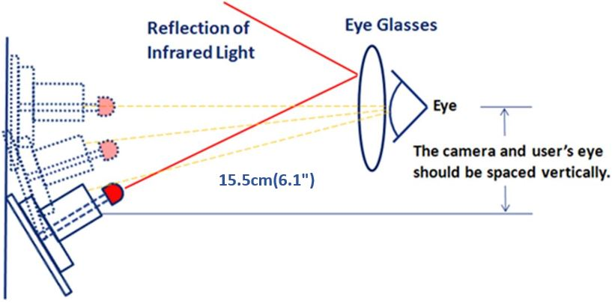

# 11 FAQ

## 11.1 Questions about the Camera Hardware

1. May I use a USB Hub to connect the camera to my PC?

A. We do not recommend operating the device through a USB Hub.

2. How long may I operate the camera continuously?

A. There is no limitation when operating under normal conditions.

3. What environment is required for operating the camera?

A. For data storage: -20°C to +60°C

For operation: 0°C to +50°C

0% to 90% humidity, non-condensing

4. Is the infrared LED light of the camera harmful to the eyes?

A. No, it emits very low infrared light (less than 2% of the LED Eye Safety Standard Regulation). It is harmless to a user’s eyes, but it could lead to eye fatigue if stared at for a long period of time. It is advisable to capture iris images as quickly as possible.

5. How can I check if the camera is connected properly?

A. You can verify the connection in the Device Manager provided by MS Windows.

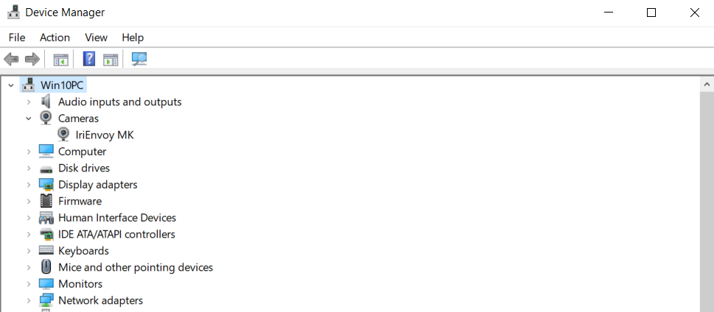

6. What if the image produced has spots or the appearance of dust?

A. Examine the camera’s mirror for dust or dirt. Clean the outside of the mirror with a cloth approved for optical use. If this does not correct the problem, dust may have become trapped underneath the mirror (between the mirror and lens). The mirror will need to be carefully removed. Clean the lens and mirror, then replace the mirror.

## 11.2 Questions about Software Installation

1. What kind of operating system is required?

A. MS Windows 32bit/64bit

2. How can I check if the demonstration software is installed properly?

A. Verify if files are in the folder under the address “C:\Program Files (x86)\IriTech\IriEnvoy-MK Iris Capture Demo” (refer to Section 6.2 “Capture Demo Software Installation”).

3. How can I check if the software is completely deleted after I remove the demonstration program?

A. Verify if files are in the folder under the address “C:\Program Files (x86)\IriTech\IriEnvoy-MK Iris Capture Demo”.

## 11.3 Questions about Image Files

1. Where is the captured image stored?

A. “C:\Program Files (x86)\IriTech\IriEnvoy-MK Iris Capture Demo\ResultImage”

(The “ResultImage” folder is automatically generated once run the demonstration program as administrator with iris image is captured and press the “get” button.)

2. Can users change the file in which the captured images are stored?

A. No, this is not possible using the minimal functions available within the demonstration software. However, you can create your own Iris Recognition Application using the IriEnvoy-MK C++SDK.

3. Can users specify the image name that will be captured?

A. No, this is not possible using the minimal functions available within the demonstration software. However, you can create your own Iris Recognition Application using the IriEnvoy-MK C++ SDK.

4. If I uninstall the demonstration software, is the image database also deleted?

A. No, the database is still saved in file “C:\Program Files (x86)\IriTech\IriEnvoy-MK Iris Capture Demo \ResultImage”.

## 11.4 Questions about the Image Capture Process

1. Can I capture high quality iris images if the user is wearing glasses or contact lenses?

A. Glasses should not interfere with the image capture, but the iris pattern may be affected by glare off the glasses depending upon the situation. We recommend removing glasses, especially before enrollment. It is also possible to adjust the equipment as seen in Section 9.5 “Preventing Reflection on Glasses” to improve the image quality.

Soft contact lenses are not likely to cause problems. Hard contact lenses can create glare that covers part of the iris and makes capture more difficult.

2. Is the iris affected by Lasik eye correction, or any other correction surgery, or by disease?

A. Disease or surgery that covers over or changes the iris pattern may interfere with iris recognition. However, most eye surgery or disease does not have these impacts. For example, Lasik eye correction should not cause any changes to the iris. An example of surgery that might cause challenges is intraocular implants. These implants are similar to hard contact lenses and may cause glare that makes capture more difficult.

3. Why does the user have to move slowly forward during the capture procedure?

A. To begin capture, the user must be at the appropriate capture distance and in complete focus. Moving forward slowly is the best way to achieve the right distance.

4. Although the iris camera is indoors, there is a reflection on the iris image. What should I do?

A. The problem may be caused by another source of light such as fluorescent bulbs, sunlight from a window, or the reflection from a mirror. Adjust the location of the camera and/or user and try to capture the image again.

5. When I use the Time-Based option on the Capture Mode setting, what is the maximum time limitation?

A. 600 seconds

6. When I use the Frame-Based option on the Capture Mode setting, is there a time limit during the capture process?

A. There is no time-limit in the demonstration program.

7. Is there any way to examine all the images captured during a particular capture process?

A. No, only the best image is saved at the end of the capture process. For example, if you specified three frames in the Frame-Based option, the capture process will stop after it selects three qualified frames. It will then choose the best frame and save that to the computer. The other captured images will be discarded.

# 12 Legal Notice

## 12.1 Warranty Agreement

|  |  |
| --- | --- |
| IriEnvoy-MK | |
| Warranty Length | 1 Year Limited: Parts & Labor, Mail in or Carry in |
| Hardware Technical Support | 1 Year |
| Software Support | 90 days |
| Website | http://www.iritech.com |
| Service Phone Number | +1 703 877 2135 (United States)  +82 2 872 3812 (Korea) |

**THIS AGREEMENT CONTAINS A MANDATORY AND BINDING ARBITRATION PROVISION IN WHICH YOU AND IRITECH AGREE TO RESOLVE ANY DISPUTES BETWEEN YOU AND IRITECH BY BINDING ARBITRATION. PLEASE SEE SECTION 10 BELOW.**

This Agreement (“Agreement”) is between the original purchaser (“You”) and IriTech, Inc. (“IRITECH”) and applies to IRITECH products (“Products”) and services purchased by you from IRITECH or affiliates or an IRITECH authorized reseller (“Reseller”). This limited warranty extends only to You, the original purchaser, and is not transferable to anyone who subsequently purchases, leases, or otherwise obtains the Product from You.

The term of this Limited Warranty (the “Limited Warranty Period”) is identified in the reference table included with this Agreement (Warranty Reference Table”). The Limited Warranty Period commences on the date of purchase by You. Your original purchase invoice (sales receipt) showing the date of purchase of the Product is your proof of the date of purchase.

1. **Product Limited Warranty.** IRITECH warrants that its Products will be free from defects in materials and workmanship for the Limited Warranty Period. During the Limited Warranty Period, IRITECH will, as its option; (i) provide replacement parts necessary to repair the Product; (ii) repair the Product or replace it with a comparable product; or (iii) refund the amount You paid for the Product, LESS DEPRECIATION, upon its return. Replacement parts and Products will be new or serviceably used, comparable in function and performance to the original part or Product and warranted for the remainder of the original warranty period or, if longer, 90 days after they are shipped to you.
2. **Technical Support.** During the Limited Warranty Period, IRITECH will provide product technical support by e-mail. The scope of technical support consists of helping you diagnose and resolve problems with defects in Products covered by this Agreement, and, for Camera Products, reinstalling the factory-installed operating system and software to restore it to the original factory configuration. IRITECH may provide technical support via on-line and other methods. IRITECH may change the means through which it provides technical support at any time.
3. **THIS LIMITED WARRANTY DOES NOT COVER MISUSE OR MINOR IMPERFECTIONS IN UNITS THAT MEET DESIGN SPECIFICATIONS OR IMPERFECTIONS THAT DO NOT MATERIALLY ALTER FUNCTIONALITY.**

**THIS LIMITED WARRANTY DOES NOT COVER AND IRITECH IS NOT RESPONSIBLE FOR:**

• DAMAGES CAUSED BY MISUSE, ABUSE, ACCIDENTS, FIRE, THEFT, DISAPPEARANCE, MISPLACEMENT, POWER SURGES, VIRUSES, RECKLESS, WILLFUL, OR INTENTIONAL CONDUCT.

• DAMAGES CAUSED BY SERVICING NOT AUTHORIZED BY IRITECH.

• DAMAGES CAUSED BY USAGE THAT IS NOT IN ACCORDANCE WITH PRODUCT INSTRUCTIONS.

• DAMAGES CAUSED BY FAILURE TO FOLLOW THE PRODUCT INSTRUCTIONS OR FAILURE TO PERFORM PREVENTIVE MAINTENANCE.

• DAMAGES CAUSED BY THE COMBINATION OF IRITECH PRODUCTS WITH OTHER NON-IRITECH BRANDED PRODUCTS, ACCESSORIES, PARTS OR COMPONENTS.

• SOFTWARE, INCLUDING THE OPERATING SYSTEM AND SOFTWARE ADDED TO YOUR PRODUCT THROUGH OUR FACTORY-INTEGRATION SYSTEM, THIRD-PARTY SOFTWARE, OR THE RELOADING OF SOFTWARE.

• ANY EQUIPMENT OR COMPONENTS THAT WERE NOT INCLUDED IN YOUR PRODUCT AS ORIGINALLY SOLD TO YOU.

• NORMAL WEAR AND TEAR.

• COSMETIC DAMAGE THAT DOES NOT AFFECT FUNCTIONALITY.

• PRODUCTS WHERE THE IRITECH SERIAL NUMBER IS MISSING, ALTERED OR DEFACED.

1. **Instructions for Warranty Service.** For specific instructions on how to obtain warranty service for your product, please refer to the Warranty Reference Table contained in this Agreement and go to: <http://www.iritech.com>.

**To obtain warranty service:**

• You must assist IRITECH in diagnosing issues with your product and follow IRITECH’s warranty processes.

• You must obtain warranty service from IRITECH or an authorized service center specified by IRITECH. IRIECH will not reimburse you for service performed by others.

• You may be required to deliver and retrieve your product to and from IRITECH or an authorized service facility specified by IRITECH at your expense. When sending a product to IRITECH or the authorized service facility specified by IRITECH, you must deliver the product, freight prepaid, in either its original packaging or packaging affording an equal degree of protection. You are responsible for properly packaging your product, paying all shipping costs, loss or damage to the product during shipping, and any other taxes, fees or charges associated with transporting the product to an authorized IRITECH service facility. **YOU ARE RESPONSIBLE FOR ANY DAMAGE TO YOUR IRITECH PRODUCT DURING SHIPMENT TO US.**

• Before providing your product to IRITECH for service, remove any confidential, proprietary or personal information.

• If IRITECH asks you to return defective parts or products, you must do so within 7 days after you receive the replacement parts or products. IRITECH will charge you for replacement parts or products if you fail to do so.

IT IS YOUR RESPONSIBILITY TO BACK UP THE CONTENTS OR DATA RECORDED ON THE DEVICE BEFORE SERVICES ARE PERFORMED AND REMOVE ANY DATA FROM PARTS OR PRODUCTS RETURNED TO IRITECH. It is possible that the contents recorded will be lost or reformatted in the course of service and IRITECH will not be responsible for any damage to or loss of any programs, data, or other information stored on any media or any part of any product serviced. IF DURING THE REPAIR OF THE PRODUCT THE CONTENTS OF THE DEVICE ARE ALTERED, DELETED, OR IN ANY WAY MODIFIED, IRITECH IS NOT RESPONSIBLE FOR ANY LOSS OF YOUR DATA WHATSOEVER. YOUR PRODUCT WILL BE RETURNED TO YOU CONFIGURED AS ORIGINALLY PURCHASED (SUBJECT TO AVAILABILITY OF SOFTWARE).

1. **Implied Warranties. EXCEPT TO THE EXTENT PROHIBITED BY APPLICABLE LAW, ANY IMPLIED WARRANTY OF MERCHANTABILITY OR FITNESS FOR A PARTICULAR PURPOSE IS LIMITED IN DURATION TO THE DURATION OF THIS WARRANTY.**

Commercial Purchasers: IRITECH extends the above limited warranty to purchasers of Products for industrial, commercial and business use upon the same terms and conditions and exclusions applicable to consumer purchasers. **HOWEVER, WITH RESPECT TO COMMERCIAL PURCHASERS, ALL IMPLIED WARRANTIES, INCLUDING THE IMPLIED WARRANTIES OF MERCHANTABILITY AND FITNESS FOR A PARTICULAR PURPOSE, ARE EXCLUDED AND DISCLAIMED.**

1. **Limitation of Liability. IRITECH SHALL NOT BE LIABLE FOR ANY INCIDENTAL OR CONSEQUENTIAL DAMAGES FOR BREACH OF ANY EXPRESS OR IMPLIED WARRANTY.** IRITECH’S AND YOUR MAXIMUM LIABILITY TO THE OTHER IS LIMITED TO PURCHASE PRICE YOU PAID FOR PRODUCTS OR SERVICES PLUS INTEREST ALLOWED BY LAW. NEITHER YOU NOR IRITECH IS LIABLE TO THE OTHER IF YOU OR IT ARE UNABLE TO PERFORM DUE TO EVENTS YOU OR IT ARE NOT ABLE TO CONTROL, SUCH AS ACTS OF GOD OR FOR VIRUSES, PROPERTY DAMAGE, LOSS OF USE, INTERRUPTION OF BUSINESS, LOST PROFITS, LOST DATA OR OTHER CONSEQUENTIAL, PUNITIVE OR SPECIAL DAMAGES, HOWSOEVER CAUSED, WHETHER FOR BREACH OF WARRANTY, CONTRACT, TORT (INCLUDING NEGLIGENCE), STRICT LIABILITY OR OTHERWISE.

Some states or jurisdictions do not allow the exclusion or limitation of incidental or consequential damages, or allow limitations on how long an implied warranty lasts, so the above limitations may not apply to you. This Limited Warranty gives you specific legal rights and you may have other rights which vary from state to state or jurisdiction to jurisdiction.

1. **Binding Arbitration.** THIS AGREENET PROVIDES THAT ALL DISPUTES BETWEEN YOU AND IRITECH WILL BE RESOLVED BY MANDATORY AND BINDING ARBITRATION TO THE FULLEST EXTENT PROVIDED BY LAW. YOU THUS GIVE UP YOUR RIGHT TO GO TO COURT TO ASSERT OR DEFEND YOUR RIGHTS UNDER THIS AGREEMENT (EXCEPT FOR MATTERS THA MAY BE TAKEN TO SMALL CLAIMS COURT AS FURTHER SET FORTH BELOW IN THIS SECTION 7).

To the fullest extent provided by law, and except as otherwise provided below, You and IRITECH agree that any Dispute between You and IRITECH will be resolved exclusively and finally by binding arbitration administered by the American Arbitration Association (AAA) and conducted in accordance with AAA’s Supplementary Procedures for Consumer-Related Disputes of the Commercial Arbitration rules and the Consumer Due Process Protocol. YOUR RIGHTS WILL THEREFORE BE DETERMINED BY A NEUTRAL ARBITRATOR AND NOT A JUDGE OR JURY. You and IRITECH will agree on another arbitration forum if AAA ceases operations.

The arbitration will be conducted before a single arbitrator, and will be limited solely to the Dispute between You and IRITECH. Arbitration is a process whereby a dispute is submitted to an arbitrator, for a final and binding determination, known as the award. The arbitrator is an individual, similar to a judge, who reviews and weighs evidence provided by both parties, and renders an award enforceable in court. Arbitrator decisions are as enforceable as any court order and are subject to VERY LIMITED REVIEW BY A COURT. YOU ACKNOWLEDGE THAT, BY WAY OF THIS AGREEMENT, YOU AND IRITECH WAIVE ALL RIGHTS TO A JURY TRIAL.

The arbitration, or any portion of it, will not be consolidated with any other arbitration and will not be conducted on a class-wide or class action basis. The arbitration shall be held at any reasonable location near your residence by submission of documents, by telephone, online or in person whichever method of presentation You choose. Under the AAA Supplementary Procedures for Consumer-Related Disputes and Consumer Due Process Protocol, You retain the right to seek relief in a small claims court for Disputes within the scope of the small claims court’s jurisdiction. If you prevail in the arbitration of any Dispute with IRITECH, IRITECH will reimburse You for any fees You paid to AAA in connection with the arbitration.

Any decision rendered in such arbitration proceedings will be final and binding on the parties, and judgment may be entered thereon in any court of competent jurisdiction.

Should either party bring a Dispute in a forum other than AAA, the arbitrator may award the other party its reasonable costs and expenses, including legal fees, incurred in staying or dismissing such other proceedings or in otherwise enforcing compliance with this dispute resolution provision. **You understand that, in the absence of this provision, you would have had a right to litigate disputes through a court**, including the right, if any and subject to the rules of your jurisdiction, to litigate claims on a class-wide or class-action basis, **and that you have expressly and knowingly waived those rights and agreed to resolve any Disputes through binding arbitration in accordance with the provisions of this paragraph.**

This arbitration provision shall be governed by the Federal Arbitration Act, 9 U.S.C. Section 1, *et seq*. For the purposes of this provision, the term “Dispute” means any dispute, controversy, or claim arising out of or relating to (i) this Agreement, its interpretation, or the breach, termination, applicability or validity thereof, (ii) the related order for, purchase, delivery, receipt or use of any product or service from IRITECH, or (iii) any other dispute arising out of or relating to the relationship between you and IRITECH; the term “IRITECH” means IRITECH, Inc, its parents, subsidiaries, affiliates, directors, officers, employees, beneficiaries, agents, assigns, component suppliers (both hardware and software), and/ or any third party who provides products or services purchased from or distributed by IRITECH; and the term “You” means the original purchaser and those in privacy with the original purchaser, such as family members or beneficiaries. Information may be obtained from the AAA online at www.adr.org, by calling 800-778-7879 or writing to American Arbitration Association, 1633 Broadway, 10th Floor, New York, NY, 10019.

1. **General.** IRITECH may assign this Agreement and/or any associated service plan without your consent and without notice to you. If IRITECH does assign this Agreement and/or any associated service plan, the assignee will assume all obligations to You, IRITECH will be released of all obligations, and You agree to look solely to the assignee for the performance of all obligations under this Agreement and/or any associated service plan. IRITECH, Inc. and its subsidiaries and affiliates are intended beneficiaries of this Agreement. If there is any inconsistency between this Agreement and any other agreement included with or relating to products or services purchased from IRITECH, this Agreement shall govern. This Agreement may not be modified, altered or amended without the written agreement of IRITECH. Any additional or altered terms shall be null and void, unless expressly agreed to in writing by IRITECH. If any term of this Agreement is illegal or unenforceable, the legality and enforceability of the remaining provisions shall not be affected or impaired. This Agreement shall be interpreted under the laws of the State of South Dakota, without giving effect to conflicts of law rules.
2. **Privacy Notice.** You can review IRITECH’s Privacy Policy on our website, located at [www.iritech.com](http://www.iritech.com). IRITECH will maintain and use your customer information in accordance with its Privacy Policy.
3. **For Residents of Canada:** This Agreement is subject to the applicable provisions of Canadian consumer protection laws that cannot be derogated from by private agreement.
4. **International Support:** You must comply with all applicable export laws and regulations if you export the product from Korea, the United States or Canada. IRITECH does not accept in return any products purchased from a reseller. Customers may be responsible for paying all freight charges incurred in shipping, importing/exporting and receiving replacement products and parts and for arranging and paying for the shipment of any defective part(s) back to the IRITECH.

All international customers are responsible for all customs duties, VAT and other associated taxes and charges.

Please send correspondence about this Agreement to:

**IRITECH Customer Service Department**

**Attn: Warranty Services**

**11166 Fairfax Boulevard, Suite 302,**

**Fairfax, VA 22030, U.S.A**

**or**

**Suite 801, Tower A, Daesung D-polis Bldg., 606,**

**Seobusaet-gil, Geumcheon-gu,**

**Seoul 08504, South Korea**

Current information on technical support and warranty policies, phone numbers and other service information is available on our websites: [www.iritech.com](http://www.iritech.com)

## 12.2 End-User License Agreement

IMPORTANT-READ CAREFULLY:

THIS IS A LEGAL AGREEMENT BETWEEN YOU (EITHER AN INDIVIDUAL OR A SINGLE ENTITY) AND IRITECH, INC. (“IRITECH”) STATING THE TERMS THAT GOVERN YOUR USE OF THIS SOFTWARE SERVICE. THIS AGREEMENT - TOGETHER WITH ALL UPDATES, ADDITIONAL TERMS, SOFTWARE LICENSES, AND ALL OF IRITECH, INC.’S RULES AND POLICIES-COLLECTIVELY CONSTITUTES THE "AGREEMENT" BETWEEN YOU AND IRITECH, INC.

IF YOU DO NOT AGREE TO THESE TERMS AND CONDITIONS, DO NOT OPEN THE PACKAGE AND DO NOT INSTALL, COPY OR USE THE SOFTWARE; YOU MAY RETURN IT TO YOUR PLACE OF PURCHASE WITHIN FOURTEEN (14) DAYS OF PURCHASE FOR A REFUND OF ITS PURCHASE PRICE. IF THE PACKAGE HAS BEEN OPENED OR THIS SOFTWARE HAS BEEN USED WITHOUT OPENING OF THE PACKAGE, YOU SHALL BE DEEMED TO ACCEPT AND AGREE TO THESE TERMS AS PRESENTED TO YOU HEREINAFTER.

1. Definitions

The following terms used in this Agreement, to all intents and purposes of this Agreement, have the meaning as specified below respectively except where the context requires otherwise:

1. “Products” means hardware products such as including, but not limited to, IriShield products, IriEnvoyl products, IriMobile products, IrisImager, any and all iris-recognition cameras that are developed and/or manufactured by IRITECH.
2. “Embedded Software” means any and all software embedded, recorded, contained or enclosed in hardware products and any related printed or electronic material developed and/or provided by IRTECH, and any updates, modifications, revisions, copies, documentation and design data of the foregoing.
3. “Supporting Software” means any and all software recorded contained or enclosed in media products and any related printed or electronic material developed and/or provided by IRTECH, and any updates, modifications, revisions, copies, documentation and design data of the foregoing. Supporting Software specifically excludes Embedded Software.
4. “Software” means any and all of Embedded Software and/or Supporting Software.
5. “License Tool” means a file or hardware device provided by IRITECH to you so that it may be used to activate the Software.
6. “Computer” means the computer, server, workstation, embedded system, or any device on which any software can be used.

Any terms used in this Agreement in the singular form includes the meaning of plural and vice versa, if the context requires.

1. OWNERSHIP, COPYRIGHT, AND INTELLECTUAL PROPERTY RIGHTS.

Although you own the hardware and/or physical media in which the Software is embedded, recorded, contained or enclosed, the Embedded Software and/or Supporting Software is the property of IRITECH.

Title to and intellectual property rights of (including copyrights to) the Embedded Software and Supporting Software, in whole and in part, and all copies thereof, and all modifications, enhancements, and other alterations (“Modifications) and derivatives of the Embedded Software and Supporting Software, if any, are, and shall remain, the sole and exclusive property of IRITECH regardless of who made such modifications or derivatives.

1. GRANT OF LICENSES.

IRITECH grants you a license authorizing the use of the Software provided that you comply with all terms and conditions of this EULA.

Nothing contained herein shall be construed as transferring any technology including patent, utility model, trademark, design, copyright or trade secrets on or relation to the Embedded Software and Supporting Software.

You may not use the Embedded Software and/or Supporting Software (i) to build any product or software that competes with Products, Embedded Software, and/or Supporting Software; or (ii) to help or assist a person, natural or legal, who directly or indirectly competes with IRITECH or its business or products. You may not use the Products and/or Software for any illegal purpose.

1. RESTRICTIONS ON USE OF SOFTWARE**.**

IRITECH licenses the Embedded Software on a per-Product basis. You may not copy the Embedded Software for any purpose.

IRITECH licenses only one copy of the Supporting Software for each Product purchased. You may install and use only one copy of Supporting Software on one Computer for each Product purchased. You may not copy the Supporting Software for any purpose.

In case there is a license activation mechanism required by IRITECH, the Supporting Software must be activated in accordance with the procedure of the License Tool provided by IRITECH.

You may not, and you will not encourage, assist or authorize any other person to modify, reverse assemble, decompile, reverse compile, or otherwise reverse engineer the Product or the Software, or attempt to discover in any way the underlying code of, the Software, whether in whole or in part, create any derivative works from or of the Software, or bypass, modify, defeat or tamper with or circumvent any of the functions or the licensing and/or Software protection mechanism of the Products.

*SOFTWARE TRANSFER.*

**Internal.** You may move the Software to a different Computer. After the transfer, you must completely remove the Software from the former Computer.

**Transfer to Third Party.** The initial user of the Software may make a one-time permanent transfer of this EULA and Software to another end user, provided the initial user retains no copies of the Software. The transfer may not be an indirect transfer such as a consignment. Prior to the transfer, the end user receiving the Software must agree to all the EULA terms.

1. TERMINATION.

Without prejudice to any other rights, IRITECH may terminate this EULA if you fail to comply with the terms and conditions of this EULA. In such an event, you must destroy all copies of the Software and all of its component parts.

1. LIMITED WARRANTY.

IRITECH warrants that any Product provided will be free from defects in material and workmanship for a period of twelve (12) months from the date of initial purchase from IRITECH, or its distributors.

THE SOFTWARE AND DOCUMENTATION IS PROVIDED “AS IS” AND WITHOUT WARRANTY OF ANY KIND, EITHER EXPRESS OR IMPLIED, INCLUDING, BUT NOT LIMITED TO, THE IMPLIED WARRANTIES OF MERCHANTABILITY, FITNESS FOR A PARTICULAR PURPOSE, AND NON INFRINGEMENT OF INTELLECTUAL PROPERTY. IRITECH DOES NOT WARRANT THAT SOFTWARE WILL MEET YOUR REQUIREMENTS OR THAT OPERATION OF SOFTWARE WILL BE UNINTERRUPTED OR ERROR FREE. IRITECH MAKES NO WARRANTIES WITH RESPECT TO SERVICES.

IN ANY CASE, IRITECH’S ENTIRE LIABILITY AND YOUR EXCLUSIVE REMEDY SHALL BE, AT IRITECH’S SOLE OPTION, EITHER:

(1) REPAIR OR REPLACEMENT, OR;

(2) REFUND OF THE PRICE PAID UPON RETURN OF SOFTWARE TO IRITECH

For the Products repaired, rectified or replaced under this Agreement shall be warranted for the balance of the original Products warranty.

1. LIMITATION OF LIABILITY.

EXCEPT WHERE THIS EXCLUSION OR RESTRICTION OF LIABILITY WOULD BE VOID OR INEFFECTIVE UNDER APPLICABLE STATUTE OR REGULATION, IN NO EVENT SHALL IRITECH BE LIABLE FOR INDIRECT, SPECIAL, INCIDENTAL, OR CONSEQUENTIAL DAMAGES (INCLUDING LOST PROFITS OR SAVINGS) WHETHER BASED ON CONTRACT, TORT OR ANY OTHER LEGAL THEORY, EVEN IF IRITECH HAS BEEN ADVISED OF THE POSSIBILITY OF SUCH DAMAGES.

ALL THE LIABILITIES ARISING OR ALLEGED IN CONNECTION WITH THE USE OF SOFTWARE SHALL NOT EXCEED THE PRICE OF RELEVANT PRODUCTS PAID BY YOU, UPON WHICH SUCH LIABILITIES ARE BASED. IF SUCH LIABILITY RELATES TO PARTICULAR ITEMS OF PRODUCTS, SOFTWARE OR SERVICES PROVIDED BY IRITECH, SUCH LIABILITY SHALL BE LIMITED TO THE PRICES OR FEES PAID FOR THE RELEVANT PRODUCTS, SOFTWARE OR SERVICES.

IN THE CASE WHERE NO AMOUNT WAS PAID, IRITECH SHALL HAVE NO LIABILITY FOR ANY DAMAGES WHATSOEVER.

THE PROVISIONS OF THIS SECTION SHALL SURVIVE TERMINATION, EXPIRATION OR CANCELLATION OF THE LICENSE AND/OR THE AGREEMENT.

1. Governing Law and Jurisdiction**.**

This Agreement shall be executed in English text as the controlling text and governed by and construed in accordance with the laws of the Commonwealth of Virginia. Any dispute, controversy or difference which may arise between the parties hereto out of or in relation to or in connection with this Agreement, Products or Software, shall be settled amicably through negotiations between the parties. If such negotiations should fail, then such disputes, controversies or differences shall be submitted to a court that has jurisdiction over the place where IRITECH has the relevant office.

1. ENTIRE AGREEMENT AND SEVERABILITY**.**

This EULA (including any addendum or amendment to this EULA which is included with the Software) is the entire agreement between you and IRITECH relating to the Software and the support services (if any) and they supersede all prior or contemporaneous oral or written communications, proposals and representations with respect to the Software or any other subject matter covered by this EULA. To the extent the terms of any IRITECH policies or programs for support services conflict with the terms of this EULA, the terms of this EULA shall control. If any provision of this EULA is held to be void, invalid, unenforceable or illegal, the other provisions shall continue in full force and effect.